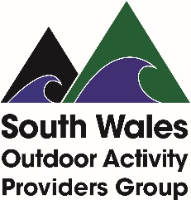

Survey of River Wye Glasbury-Hay Providers
June 2021
If you ‘regularly’ provide either craft hire or guided paddlesport activity on the River Wye between Glasbury & Hay, please complete this form and return as soon as possible to coordinator@swoapg.com to help us inform Powys County Council about patterns of usage on the river which will in turn inform their Habitat Regulations Assessment.
Please answer based on a ‘normal’ year, ignoring current Covid and access restrictions!
Name of person completing form:
e-mail address (in case we need to contact you for more detail):
Name of the organisation or business you are representing:
How would you categorise your provision (e.g. canoe hire business, private or not-for-profit outdoor education centre / activity provider; coaching provider; club; voluntary organisation; military training unit, etc.)?
NB SWOAPG will not pass on any of the above information to Powys CC – this is just to help us ensure that we group the survey data appropriately for the Council’s use.
Type of use: | Unguided craft hire | Guided activity
How often do you use the river for this type of activity?
Please provide enough detail to help us understand your ‘pattern of use’ e.g. daily; x-times a week / month / year; midweek and / or weekends; all-year or particular months, etc.
What is the typical size of groups undertaking this activity?
Typically, at your busy times, how many craft do you send down the river each day?
Are these all at once, in two or more groups (e.g. morning and afternoon), spread throughout the day, etc.?
How often would you say you are this busy?
e.g. every time you operate; half the time; only on certain days / in certain months, etc.
When you’re less busy, what does the pattern look like?
Are there particular times that you generally start launching at Glasbury and finish landing at Hay?
Is there anything else you can tell us that would help us understand your ‘pattern of use’ of the river?

