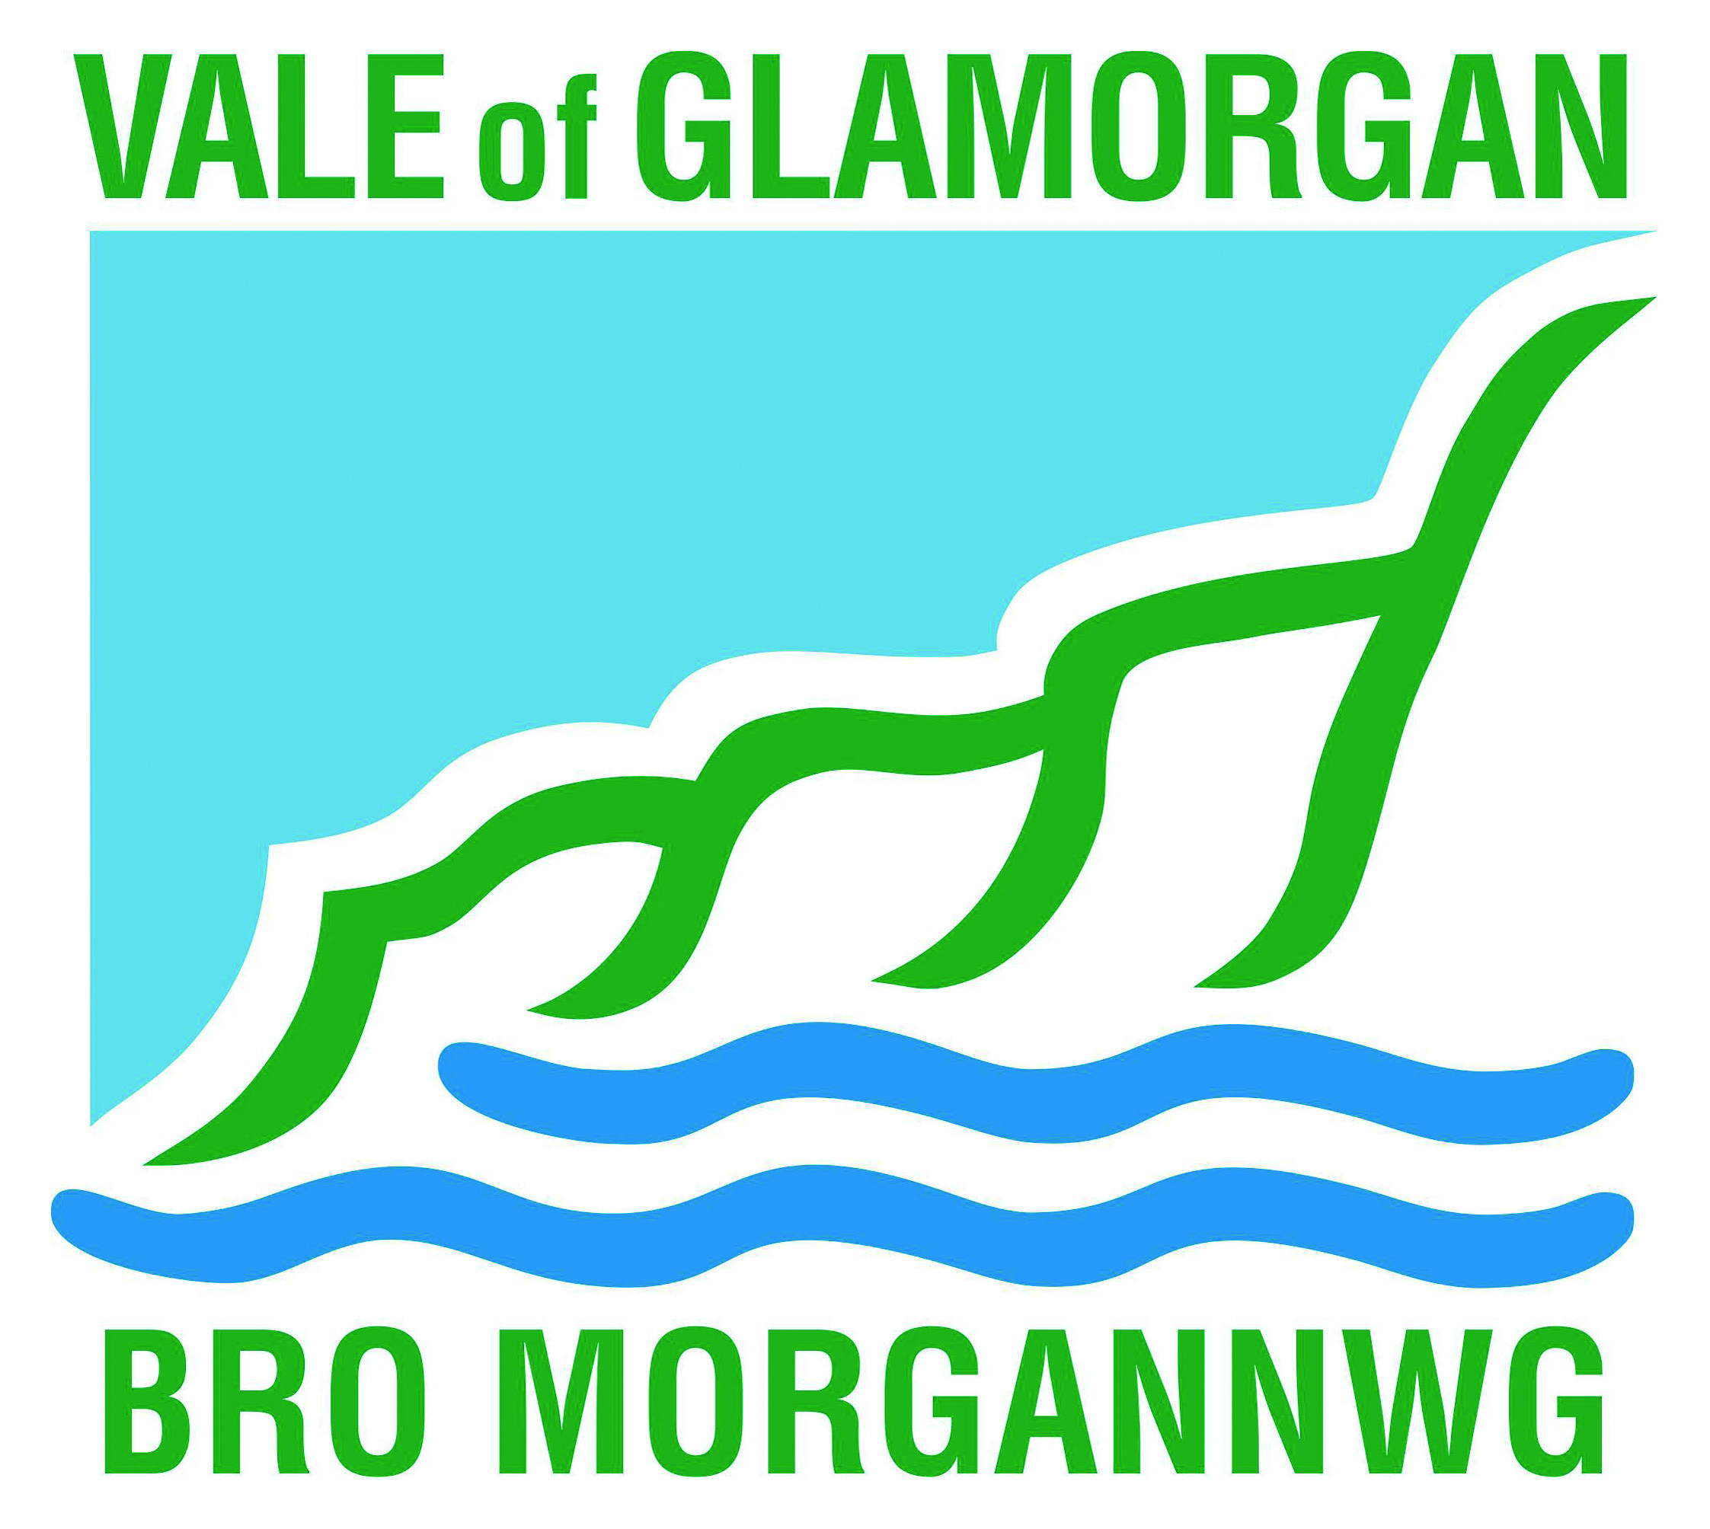

Commercial Opportunities at Vale of Glamorgan Country Parks
Have you thought about running your business from one of the Vale of Glamorgan country parks?
We are looking to work with businesses that provide the type of activities and services that will complement and enhance these amazing places and we are open to new and innovative ideas.
The Vale of Glamorgan Council own and manage two country parks; Cosmeston Lakes Country Park and Medieval Village and Porthkerry Country Park. They also own an area known as Leckwith Woods on the outskirts of Cardiff.
The parks and woodland are situated within a short distance of Cardiff, the capital of Wales, the fastest growing city in the UK, with a city region population of 1.6 million within 45 minutes’ drive of the parks. It is the short stay capital of the UK with a population of 350,000 and 70,000 students.

Our future plans include
• Working with a range of complimentary outdoor activity operators
• Providing accommodation for visitors to stay at the country parks
• Increase and develop our catering choices for visitors
• Establishing the parks as events destinations
• Promoting our unique locations and facilities to more television and film companies
• To further build our public profile working with partners and using the support of the council tourism team.

Present audience

• Local families
• Visitors from Cardiff City Region
• Education visitors, European, local, and national
• General recreational users; walkers, dog walkers
• Event visitors
• Group travel visitors

We have started to develop and transform the parks through investments made by the council and private sector partners. We are modernising the parks to meet the needs and expectations of our current and future visitors. Our commercial partners are currently looking to invest in excess of £500,000 having accessed certain funding options that are available during the course of 2017 to develop the visitor experience and provide new facilities.
We currently have over 350,000 visitors per annum who use our country parks and enjoy the unique experience they offer. With future plans in place and the support of our tourism team we expect over 500,000 visitors in the future. We are now adapting to the changes in our customers’ needs where they want to stay longer, visit more often and spend more money on new experiences and specialist activities.

These are some of the top reasons for visiting

- Family friendly, free parking, animals, wildlife and birds
- Lakes, Picnics, Barbeques, Events
- Outdoor activities such as walking, running, cycling and horse riding

To discuss the many commercial opportunities that exist or request further information contact Marc Cross Commercial Opportunities Officer mscross@valeofglamorgan.gov.uk or phone 02920 701678

